BRIEF HISTORICAL REPORT ON
THE OLD BURIAL GROUND
OF
OULTON
WORKHOUSE
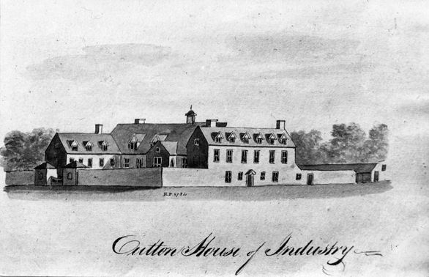
Compiled by Ivan A W Bunn for
OULTON PARISH COUNCIL
JULY 2017

BACKGROUND:
Oulton Workhouse or House of Industry was erected in 1765 by the Mutford and Lothingland Hundred Incorporation which had been created by an Act of Parliament of 15th November 1763 at a cost of £3,000. Twenty-four parishes of this Hundred were incorporated for the maintenance of the poor, namely:
Ashby, Barnby, Belton, Blundeston, Bradwell, Burgh Castle, Carlton Colville, Corton, Flixton, Gisleham, Gunton, Herringfleet, Hopton, Kessingland, Kirkley, Lound, Lowestoft, Mutford, Oulton, Pakefield, Rushmere and Somerleyton.
The workhouse, which could hold 300 inmates, consisted of a chapel, Governor’s apartments, various offices and four large working rooms stood in just under 19 acres of land. To the extreme north of these lands was a small enclosure containing just over a half acre designated as the burial ground.
The history of the workhouse is beyond the scope of this short report, suffice to say that it was enlarged in 1836 and two infirmaries were added, one in 1881 and a second in 1898. In 1893 the Incorporation which managed the Workhouse and its grounds was dissolved and replaced by the Mutford and Lothingland Poor Law Union.
Nationally, Poor Law Unions were abolished by the Local Government, 1929 which transferred responsibility for public assistance to county, and county borough councils. Under this Act in 1930 Oulton Workhouse and its administration was transferred to the East Suffolk County Council. Initially it was renamed Lothingland House and then Lothingland Hospital which provided mental health care.
The old workhouse buildings were demolished in the 1960s, but the two infirmaries remained in use for another thirty years until they too were demolished.
Later, on the eastern part of the 18 acre site, a private care home was built, with more bungalow units built on Airey Close to the north-east. After the demolition of all the buildings (including the old chapel which was the last to go) the remaining land on the western edge of the site was sold for housing development on a newly laid-out road named Flixton View. The remaining workhouse lands to the north of Flixton View (including the old burial ground) have not yet been developed but appear to be extensively used and excavated.
[NB: See aerial view on the following page for a present day perspective - Fig 1]

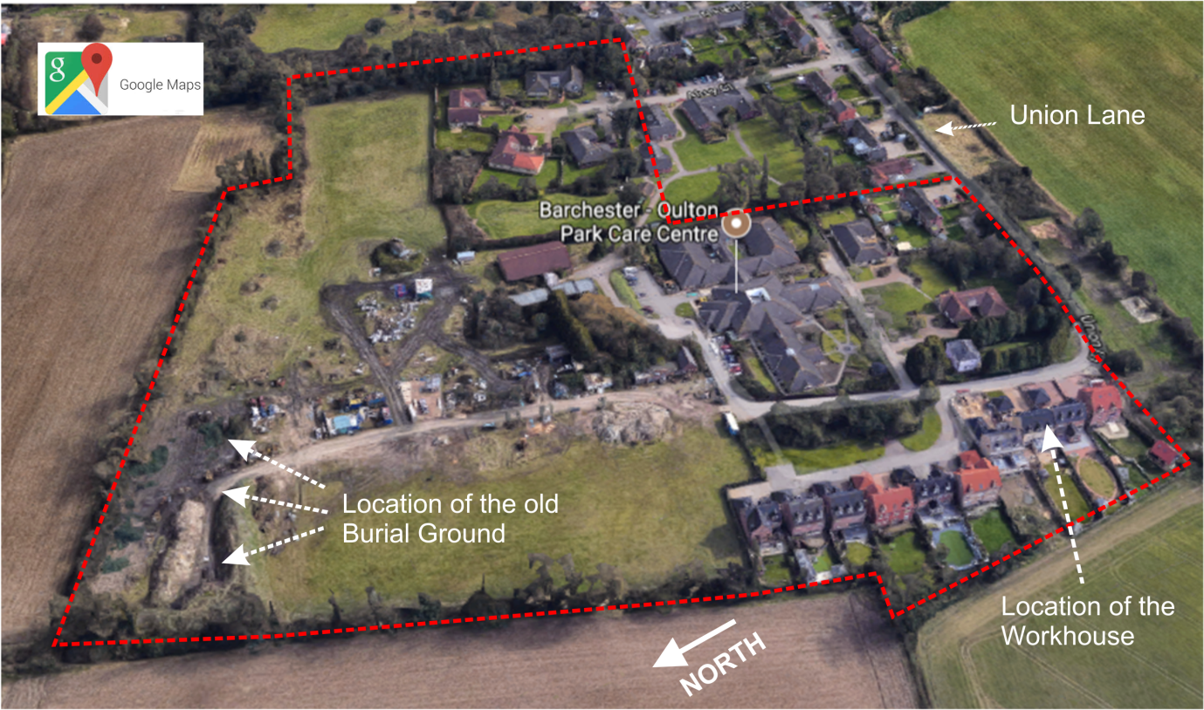
1. Aerial View of the workhouse site 2017. Original boundaries of the site are indicated by a broken red line.

THE BURIAL GROUND:
It would appear that a burial ground was incorporated into the site from the beginning in 1763 although there is no evidence to state this categorically.
The earliest reference to the burial ground here is the register of burials which commences in May 1834. This register contains the names of no less than 896 men, women and children interred here between 30 May 1834 and 5 February 1899 after which date the burial ground ceased to be used. (see below). The people buried here came from any of the parishes within the Mutford and Lothingland Incorporation and their ages ranged from 21 days to 96 years.
Almost without exception all of these people would have been paupers who had died in the workhouse and for various reasons (usually poverty) their bodies could not be returned to the town or parish in which they had resided.
The earliest identification of the Burial Ground site is on the Oulton Tithe Map and Apportionment from 1842:
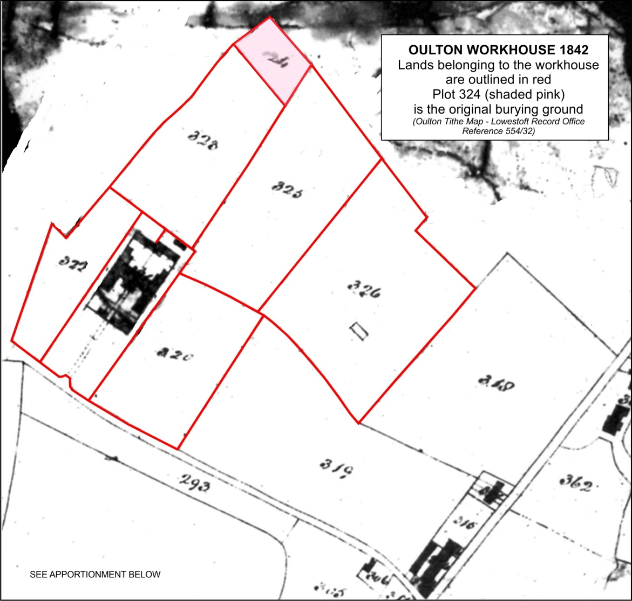
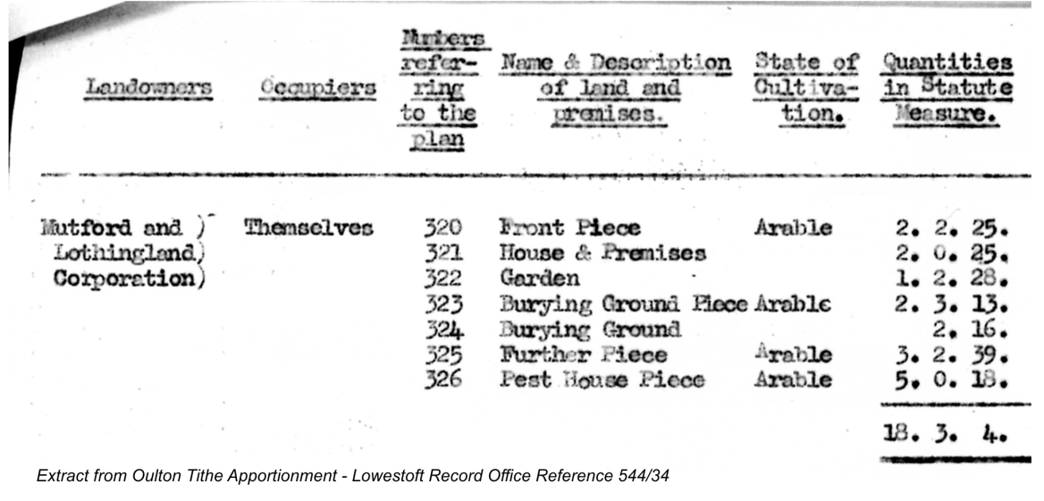
The burial plot (containing 2 roods 16 perches) is smaller than that on later maps and it would appear that it was extended eastwards at some time, probably in 1836 when the workhouse was enlarged.
The map below shows the extended burial ground in 1884:
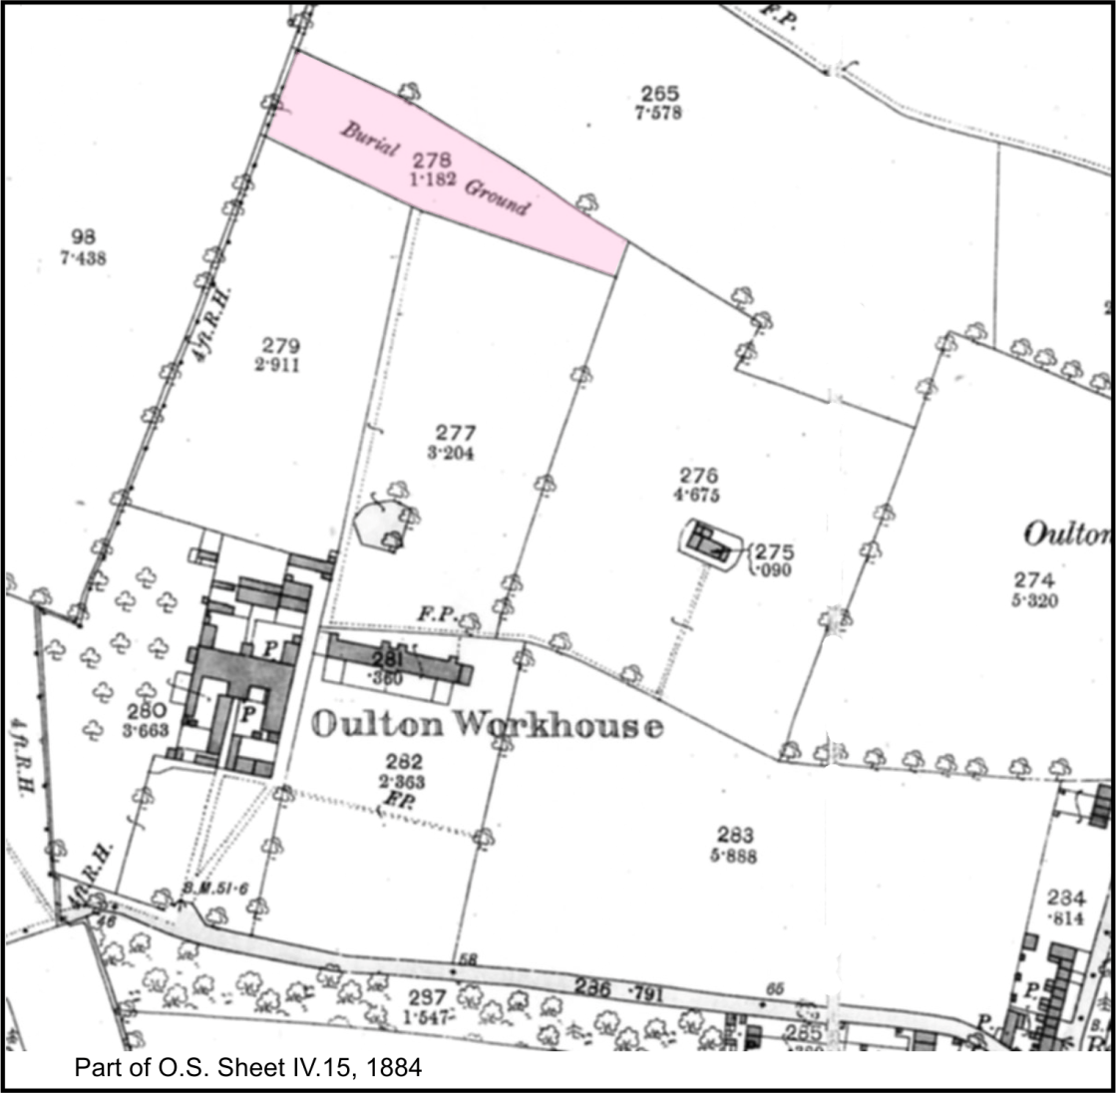

CLOSURE OF THE BURIAL GROUND:
By the early 1890s the Board of Guardians were reporting drainage problems on the burial ground. When dug, graves would rapidly fill with water and coffins had to be weighted in order to sink them! The local newspaper recorded that at a meeting of the Board of Gaurdians in 1893 it was reported that “ . . . attention was drawn to the fact that the Burial Ground at the Workhouse could not be used for more than about twelve months lomger. There were springs in the ground which penetrated into newly dug graves and filled then quite a third full of water of a most offensive nature. After some desultory conversation the subject was dropped for the present.”
At a Board meeting held on 16 January 1895 the Guardians resolved that “. . . a hole be dug in the low part of the grave yard . . . and that the same be reported upon at the next Board.” Adding that “ . . . The drainage of the upper part of the grave yard the Committee consider to be impracticable.”
At the Board Meeting held on 3 September that same year the Land Management Committee of the Board resolved that “. . . The field at the back to be drained and part of it added to the burial ground . . .”
The Minute Book remains silent on this matter until a meeting of The general Purposes Committee of the Board of Guardians on 24 February 1898 that “ . . . the committee recommend that application be made to the Local Government Boardto extend the Burial Ground to the east of the present one and to enclosed about ¾ of an acre.”
The Local Government Board responded promptly and it was minuted on 21 March 1898 that they (the LGB) “ . . . could not assent to the proposal of the Guardians to extend the present burial ground at the Workhouse.” No reason for their decision is noted. In Consequence of this it was resolved that three Lowestoft undertakers be requested to give a price for “ . . . the conveyance, by a one horse hearse, of the bodies of persons dying in the Workhouse to their respective parishes.”
Although not stated, it is obvious that the workhouse burial ground was either full or untenable and at a meeting of the Board of Guardians were looking for alternative means of burying the workhouse dead.
Nothing seems to have resulted from the above resolution, and on 6 June 1898 it was resolved that “. . . the [General Purposes] committee see the Rev. M. Kearney the Rector of Oulton and make enquiries as to fees for burial of paupers in Oulton Churchyard.
A sub-committee was appointed for this task and on 20 June 1898 they reported that they had seen the Rev. Kearney who stated that “. . . there was plenty of room in Oulton Churchyard, and that the charges for [the burial] of adults would amount to 8s. 6d. ad for children 6 shillings. It was resolved that the Committee recommend these terms to the Board Of Guardians.
From henceforth the Minute Books remain silent on the matter and it would appear that the Board of Guardians accepted the Committees recommendations and the old workhouse burial ground ceased to be used. The last person to be buried there was Jacob Crane of Burgh Castle aged 61 years. His funeral took place on 5 February 1899.
NB: It should be noted that even if the burial ground was not consecrated every person who was buried there was buried with full Christian rites by the Workhouse Pastor.
The appendix on the following pages contain maps of more recent date showing the site of the burial ground.
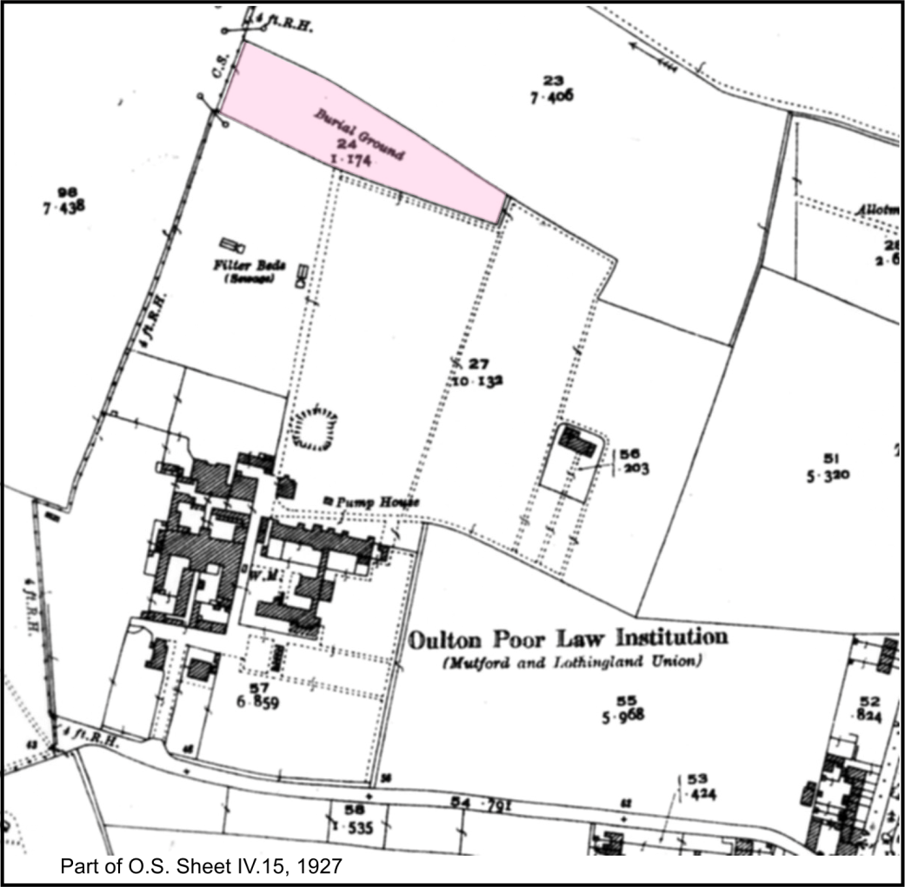

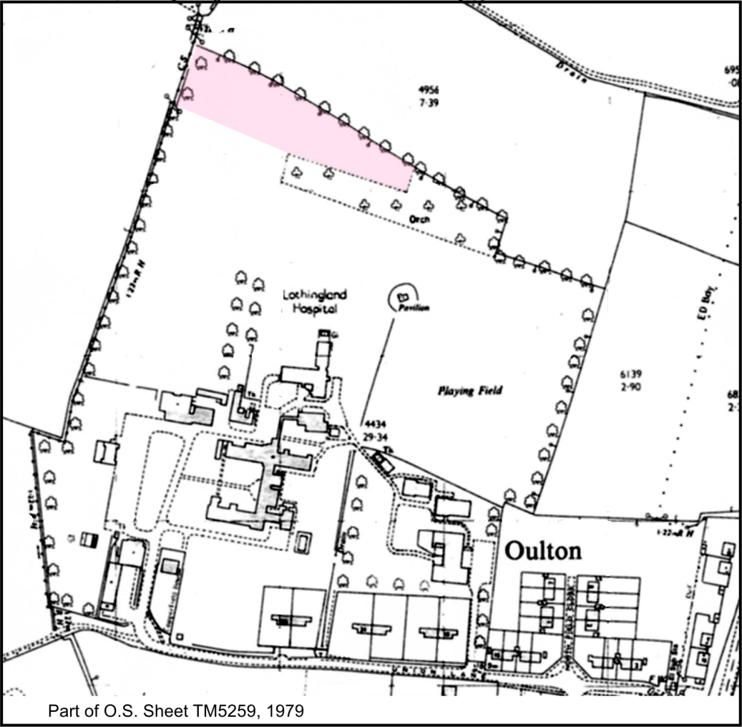

The montage above is an aerial view of the Workhouse site with the exact location of the burial ground superimposed. This leaves little doubt that the western end of the burial ground (the oldest part) was being severely disturbed by building(?) works.

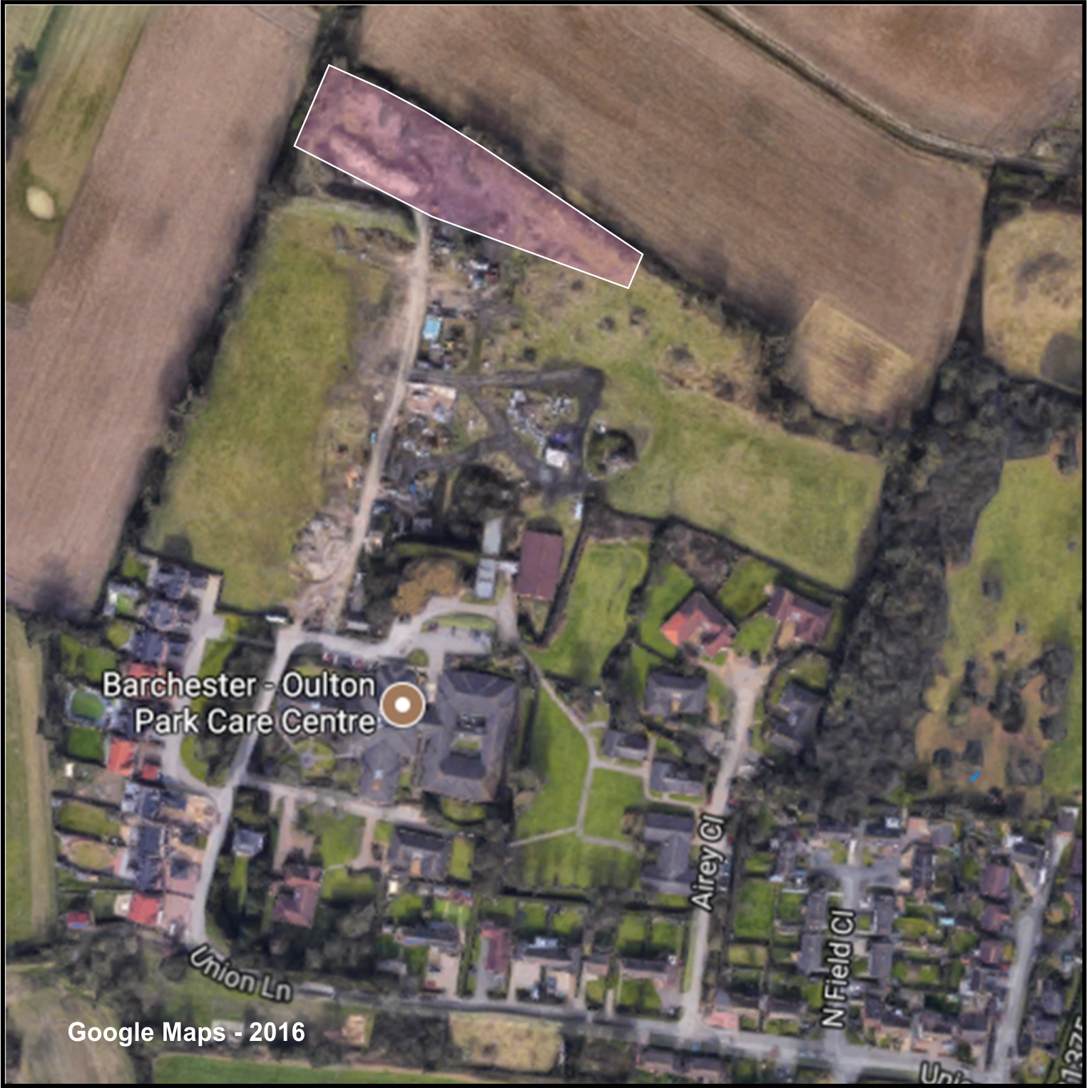

This Bill entitled: “An Act for the Better Relief and Employment of the Poor in the Hundred of Lothingland in the County of Suffolk”, passed by the House of Lords on 12th April 1864 – House of Lords Journal, Vol. 30 p. 569.
White’s 1844 Directory of Suffolk, page 481. However, according to the website http://www.workhouses.org.uk/Mutford/ the sum of £5,725 was borrowed to complete the work.
19 Geo V, Chapter 17.
Oulton Park Care Centre.
No early records of Oulton Workhouse and its environs are extant, most date from the mid-19th century onwards and are in the Lowestoft Branch of the Suffolk Record Office, collection 34. The workhouse website http://www.workhouses.org.uk/Mutford/ infers that there was a burial ground from the beginning but offers no evidence.
Lowestoft Record Office, Ref: 34/CB1/1.
It is possible that an earlier register existed but is no longer extant.
Lowestoft Record Office, Ref: 544/32 & 33.
Report in The Lowestoft Journal, 20 May 1893, page 4.
Mutford & Lothingland Incorporation Minute Book, Lowestoft Record Office, Ref: 34/AB2/2, f.1.
ibid. 34/AB2/2, f.36.
A supervisory body set up by an Act of Parliament in 1871 for “. . . the supervision of the laws relating to the public health, the relief of the poor, and local government" . It was abolished in 1919.
op cit 34/AB2/2, f.157.
ibid 34/AB2/2, f.164.
ibid 34/AB2/2, f.178.
ibid 34/AB2/2/ f. 181 & 182.

